Step 1: make a new directory with the name of “images” by right clicking the project.

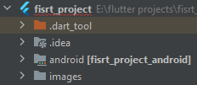

Step 2:

Copy and paste the image into images

Step 3: open the pubspec.yaml



Step 4 : search for assest

Then select assest portion and press ctrl + /

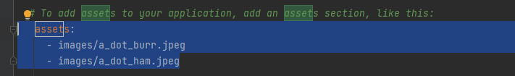

Step 5: flutter code

import 'package:flutter/material.dart';  
  
void main() {  
 runApp(  
 MaterialApp(  
 debugShowCheckedModeBanner: false,  
 home: Scaffold(  
 appBar: AppBar(  
 title: const Text('FirstApp'),  
 backgroundColor: Colors.*lightBlueAccent*),  
 body: const Center(  
 child: Image(  
 image: AssetImage('images/tech.jpg'),  
 ),  
 ),  
 ),  
 ),  
 );  
}